Name_________________________________________Height_________Weight_________

Mark the drawing below according to how you feel today.

B = Burning N = Numbness S = Stabbing A= Aching P = Pins and Needles

FRONT BACK
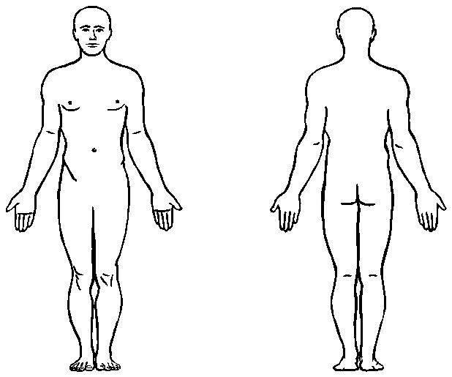

NOTICE OF PRIVACY PRACTICE
We care about our patients’ privacy and strive to protect the confidentiality of your medical information at this practice. Federal regulations require that we issue this official notice of our privacy practices. You have the right to the confidentiality of your medical information, and this practice is required by law to maintain the privacy of that protected health information. This practice is required to abide by the terms of the Notice of Privacy Practices currently in effect, and to provide notice of its legal duties and privacy practices with respect to protected health information.

If you would like to read the entire notice and/or have a copy, please inform the front desk attendant.

I have been informed that Chiropractic and Sports Injury Center of Jackson Hole has a Privacy Policy in effect. I have also been given the opportunity to read it and /or have a written copy

NAME_____________________________________________Date_____/______/________

Minor Patient Name___________________________________________ Relationship to Minor_______________________

Employee Name ______________________________________Today’s date____/____/____ SEE THE REVERSE SIDE >>

